Homepage + General texts

# LINKS

# BASIC WEB

<http://hesa.dk/index.html>

# BASIC ANIMATION

<http://hesa.dk/Wizard%20of%20OZ/Wizard%20of%20OZ/Tornado_scene_1/start_page/index.html>

/projectpool1

<http://hesa.dk/ProjectPool1/Index.html>

/projectPool2

<http://hesa.dk/project_pool_02/index.html>

# BASIC CONTENT

<http://hesa.dk/CYCLEGUIDE/FULL%20WEBSITE/index.html>

<https://xd.adobe.com/view/8e192877-ac3f-40f0-7738-bd5aaa4bd2ad-f828/screen/49f8aac3-9b09-405e-bf8a-8a4b44900f35/guide-lines?fullscreen> -XD PROTOTYPE

# BASIC UX

<http://hesa.dk/fronterPrototype/index.html> - web prototype

# WRITTENS BELOW

# WELCOME TO MY SITE

# A LITTLE ABOUT ME

* My name is Hudeifer Esa,
* I am currently a 1st semester MMD student.
* I am currently also 23 years of age
* I am learning to enjoy the mundane things in life, apparently its the best way to become an adult.
* CV

# ABOUT THIS SITE

### Moodboard

In the moodboard above, I decided

### Styletile

### Wireframes

# THEMES

## Basic Web- Homepage txt

In this theme I got to explore the basic terminology within user interface design, digital communication, user testing and responsive web design. It was a basic but intensive introduction to some of the key skillsets that spilled over to the other themes. This theme contained 4 modules:

* Content first: This module focused on creating and curating content from research on a style.
* Html and css: in this module we got our first tastes of basic html and Css.
* User interface design: in this module we learned how to create interface design without code. This includes wireframes, high and low fidelity prototypes and an introduction to working with Adobe XD.
* Responsive Web Design: In this final module of this specific theme, we learned how to make websites responsive so that they can be used on a plethora of different modern and current devices using css and media queries.

## Basic Animation- Homepage txt

In this theme, I was exposed to basic concepts of animation, classic storytelling and character design at an introductory level. I also worked with CSS animations and enhanced the activity of the animations using javascript.

## Basic Content- Homepage txt

In this theme I was introduced to concept development using video, dramaturgy, film language and media elements. As well as recording and editing techniques.

## Basic UX- Homepage txt

In this theme I gained an insight into the world of user experience design. This theme gave me a basic understanding of how interaction between users and user interfaces works best, along with theories, tools and methods that can be used to gain an insight to how users actually use the system, rather than relying on personal tastes and assumptions.

ARTICLE TEXTS

# THEMES

## THEME1-BASIC WEB

<http://hesa.dk/index.html>

In this theme I got my first introduction to basic web development and more specifically an insight into responsive web design. This site was coded using basic html and css. Using html to set out the skeleton and using Css to give the site the necessary styling. Since this site was my first go at web development, it is not inconceivable to see that its not my best work. But it did serve its purpose which was to introduce the tools and methods required to make a responsive web design. This site comes with plenty of faults and design issues, I have chosen to include them anyways as I am looking to illustrate how much I have improved in the span of a few months.

### Moodboard

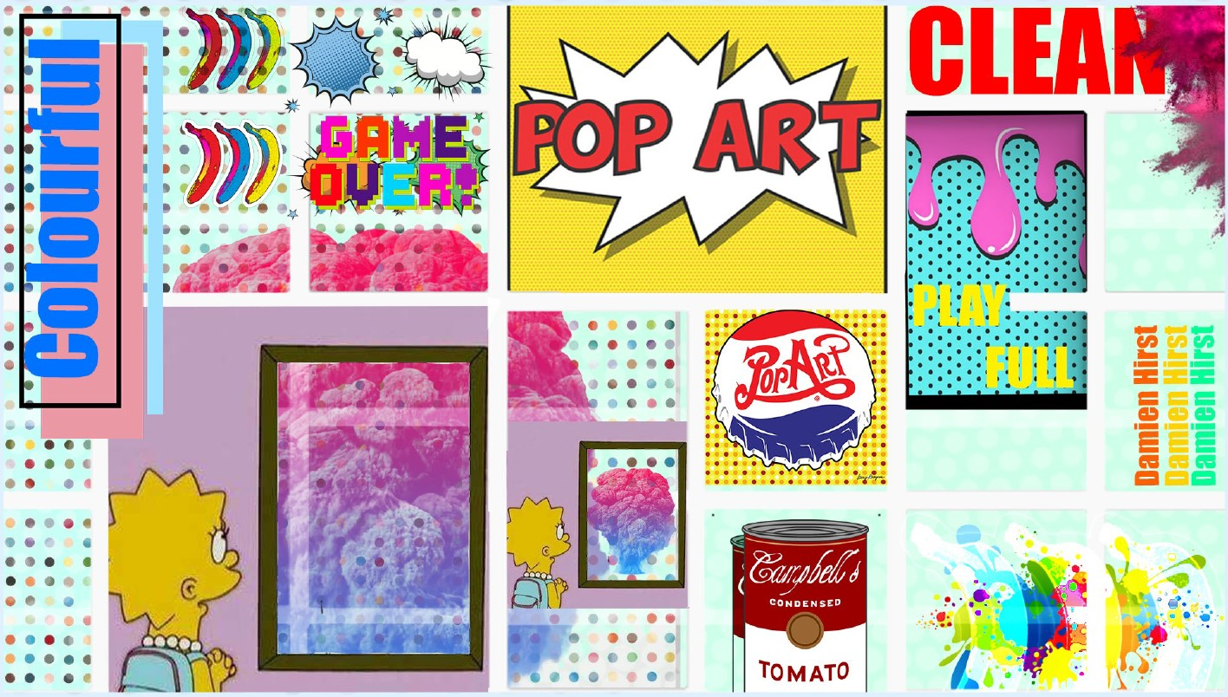

For this task I was given an art style to explore and theme my website on. The art style was pop art, after spending a little while researching what pop art actually is, I started to gain ideas of what mood the website would take on. The art style is playful, colourful, and often very clean & clear.

### Font and Typography

I decided to use the Poppins font, from the typeface family I opted for Poppins Black typeface for the Headers; I decided to use Poppins SemiBold typeface for the body texts. I think the contrast in the boldness of the strokes between the header typeface and the body typeface, clarifies to the viewer what the main content is and what the header information is. Initially I was thinking of using a font from the typeface family called impact. The clean lines and think strokes allow for easy stencilling which made it popular amongst most Pop artists. However since I’m not necessarily stencilling, rather I am creating a website, I considered using a similar typeface but one more appropriate for a website. That is how I ended with typefaces from the Poplin typeface family. I decided to go for Poplin.

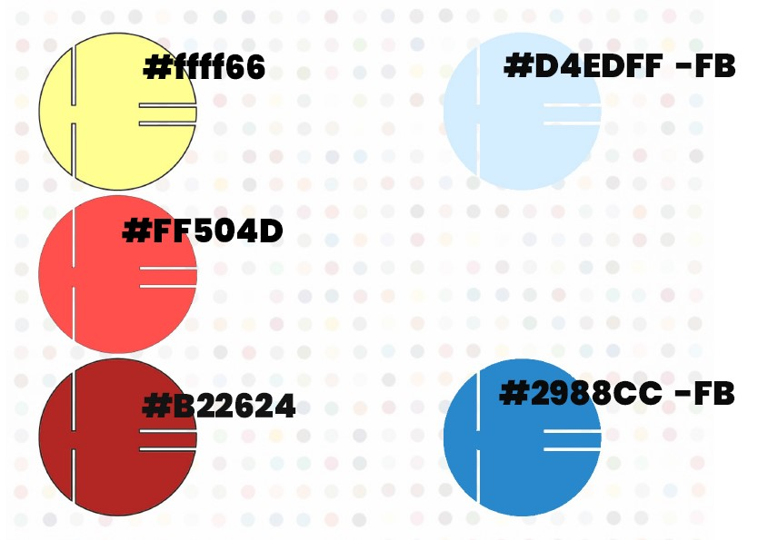

### COLOUR

I went for 5 colours, I went for a triadic colour wheel pallets: with two shades of red with varying light contrasts, two shades of blue also with varying light contrasts and finally a bright yellow. These three colours in essence are the primary colours, I plan on using the blues as foreground and background colours, with the lighter shade in the foreground. I plan on using the yellow as the main colour and have the red and blue play of off each other.

## THEME2- Basic Animation

### 02.02.01- Week submission_part one_ part two_part three

For this assignment we got to explore the basics of character design and story telling.

<Link to document>

#### Part one -story and storyboard.

For this task I was tasked with creating a story, I started of thinking about what kind of message I wanted to convey in my story. The message I wanted to convey is to show the lengths friends are willing to go for one another and that it is always better to take the shot even when the chances of success seem slim. The two main themes at play in the message of this story are very relatable as most humans have friends and most people are faced at some point in their lives with obstacles that can make you want to give up.

For this reason I decided to play further on the message of the story in terms of its relatability and chose to make the main display of friendship between tow characters, a robot and his owner/friend. This is intended to create some distance between the consumer and the actual story relying on the message to be the most relatable aspect of the story.

I then went on to create the storyboard and the flow of the story starts to become clear. Every scene has been annotated with regards to action/plot, interactive elements, sound/music and duration of the scene. You can find an example below.

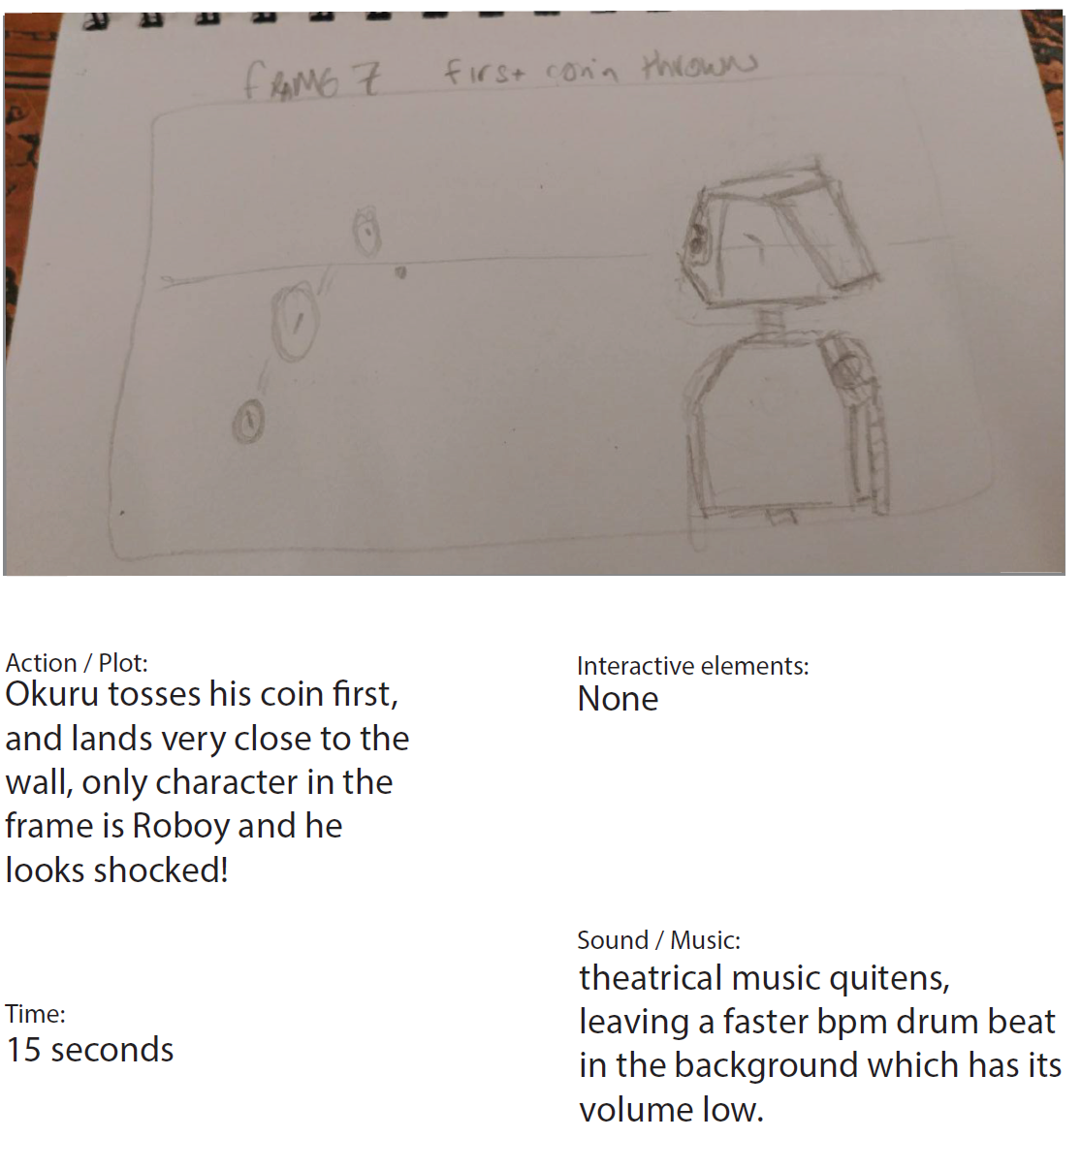

By completing the storyboard I gained insight into how the story could flow best, as it became clear to me which parts of the story were important for the message to come across and which parts were not.

#### Part two

Style tile and worksheet

I was presented a selection of styles and artist which I could draw inspiration from, I chose to go with flat design as it was what felt the most accurate for my story. I also included a font style which was Open Sans, I chose this font with readability in mind. I opted for a very readable and simple font which would not take the user away from the story and the message of the story.

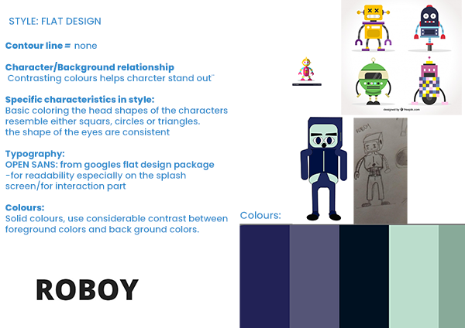

I then went on to flesh out my characters using a provided worksheet to guide me.

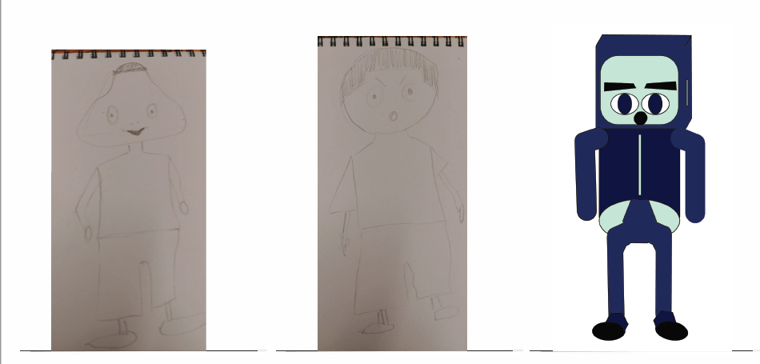

From left to right the characters are Okuru, Jaja and Roboy. Only Roboy is completely fleshed out, the other two although designed are not completely fleshed out. Aside from that fact, I decided to give okuru a triangular shaped head, the reason is for that is to illustrate that he is a little shady, his eyes are also designed to be smaller, so that the consumer/viewer does not necessarily feel attached to him. As for Jaja, the only seeming human character, I decided to give him a very large head, which gives him a child like quality, this is so that the viewer can feel most alike Jaja than the other two. The reason he is the one with the most humanoid features is to do with his role in the story as his role is intended to be an embodiment of what it is to be humane, which is to be kind to everything including Robots.

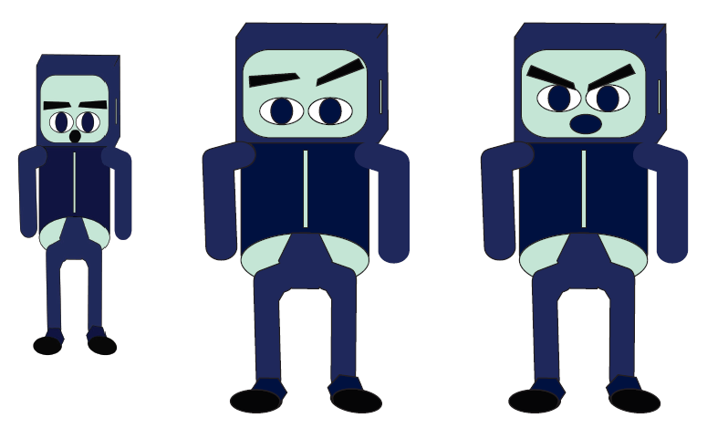

Above is an image of Roboy in different expressions, and below is an all round view of his build.

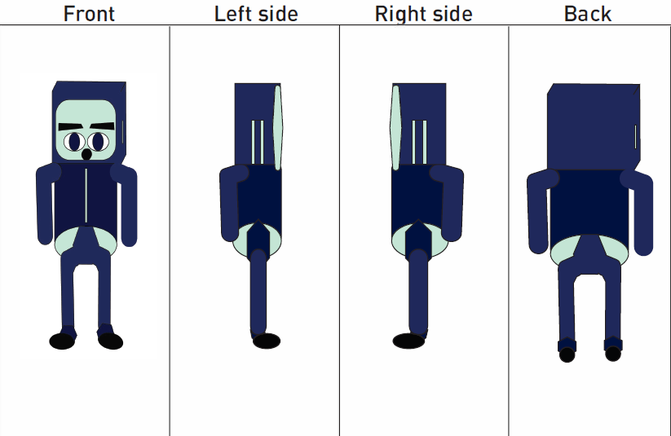

#### Part three – sprite sheet animation

<link to sprite animation>

The last part of this assignment was to create a sprite sheet animation. Since this was my first ever attempt at creating a sprite animation, I decided to focus on a scene where Roboy is walking.

### 02.04.06 Link to Final Interactive Production

<link>

### 02.04.07 Presentation (short process documentation) pdf

<create pdf, host on website and create a link>

## Theme 03: Basic Content

In this theme, for our group project we was tasked with creating an informational brochure based on cycling in Copenhagen for a specific target group. The target group we decided too pick was young tourists visiting Copenhagen. The reason we decided to focus on this group was simply most of our team was inexperienced cyclers, especially in Copenhagen. We felt the natural learning journey we would undertake would present natural opportunity to be most informative in our brochure.

### 03.02.01 Team Canvas

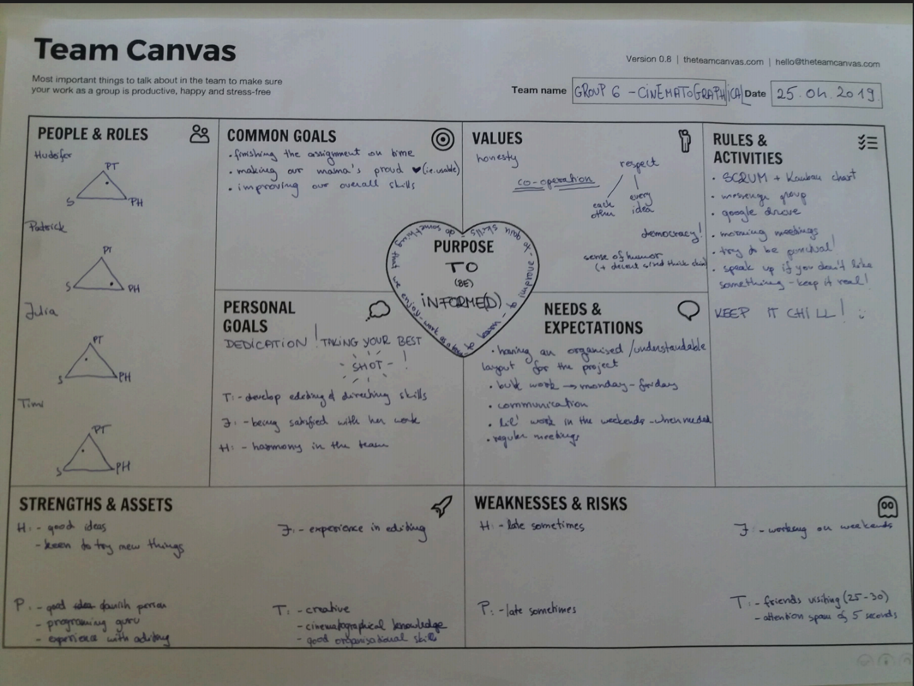

We created a team canvas to align our goals, ambitions, interests and desired roles. In the people and roles section right at the top, you can see my name and role which is closest to a ponytail.

### 03.02.03 Storyboard

As part of our task, we were tasked with creating a video guide as part of our brochure. In our storyboard you can see we considered things such as the duration-length, shot angle and size, camera movement whether or not there are transition, props and/or audio. We considered the language and what we were going to communicate to the viewer when doing the storyboard, and we decided to stick to an advert styled, story of a local and a tourist who just landed. The focus of the story is on their journey to a specified park in Copenhagen, both of them using cycling as a means of transport. The local has a relatively easy time as they know how cycling in Copenhagen is, on the other hand the tourist does not necessarily know what cycling in Copenhagen is like. The tourist has a tough time as he breaks rules and actually arrives later than the local. The idea of the story is to illustrate how knowing the rules and following them can actually cycling in Copenhagen. The shots are dynamic, changing consistently back and forth between the characters to compare their journeys.

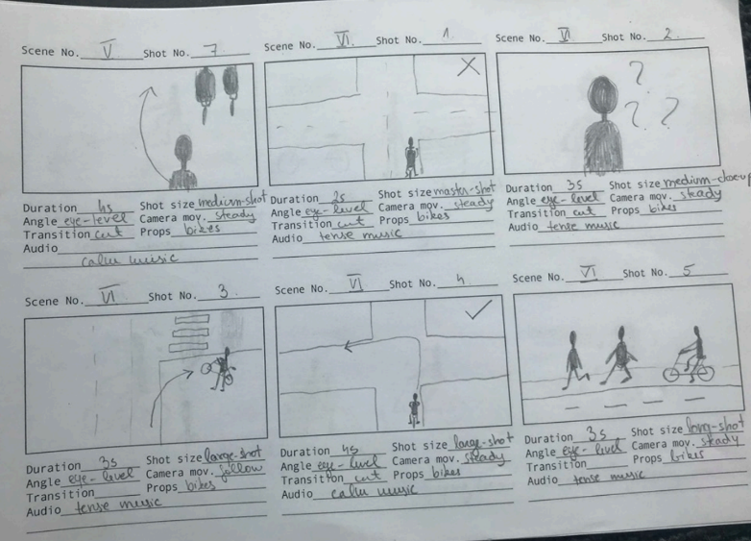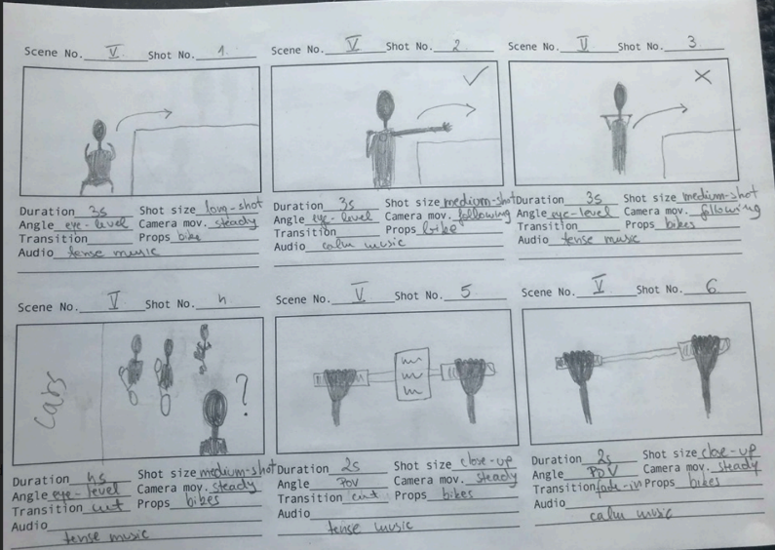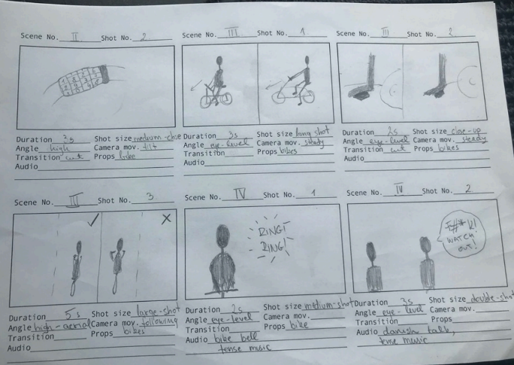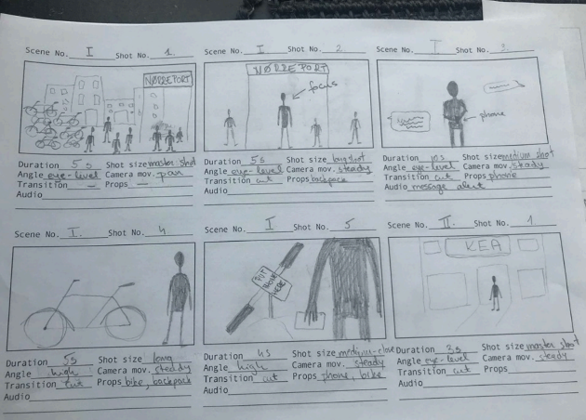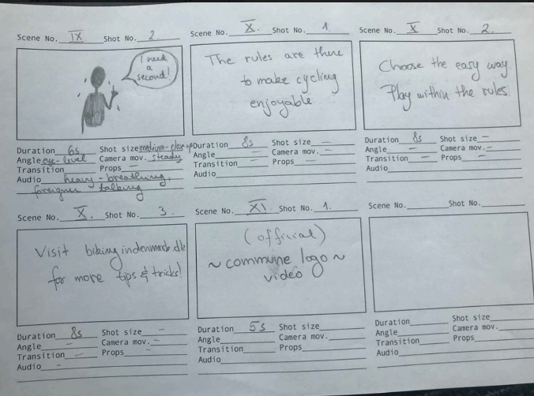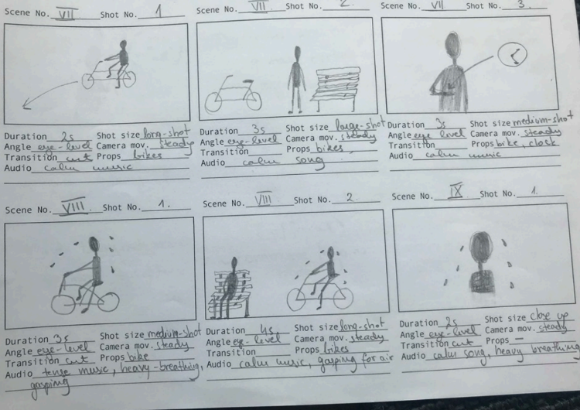

### 03.02.04 XD Prototype

We created a prototype using xd for our brochure site, following Copenhagen’s municipality’s guide.

#### Style Tile and Moodboard

Below you can see the moodboard you can see we decided to hone on mood that was informative and felt affordable, safe and easily available. We wanted the end user to feel all these qualities, whilst still using the design guide provided.

The moodboard then fuelled a more technical style tile that is heavily influenced by the style guide provided.

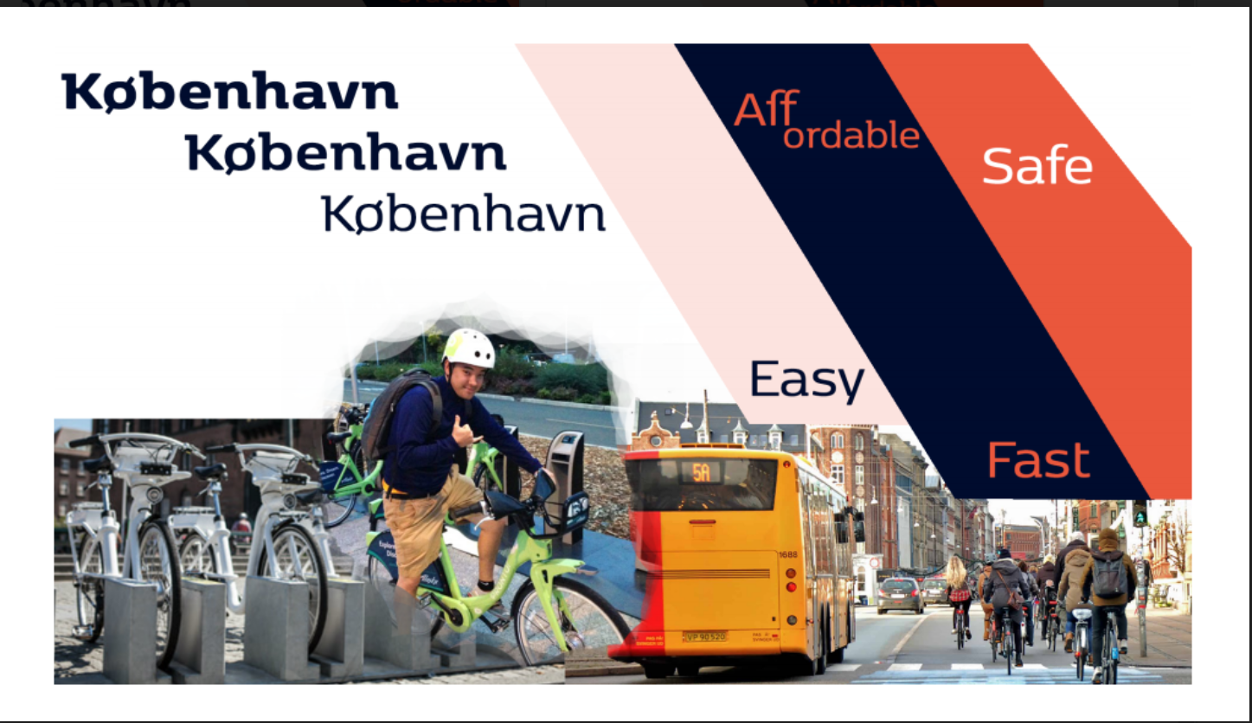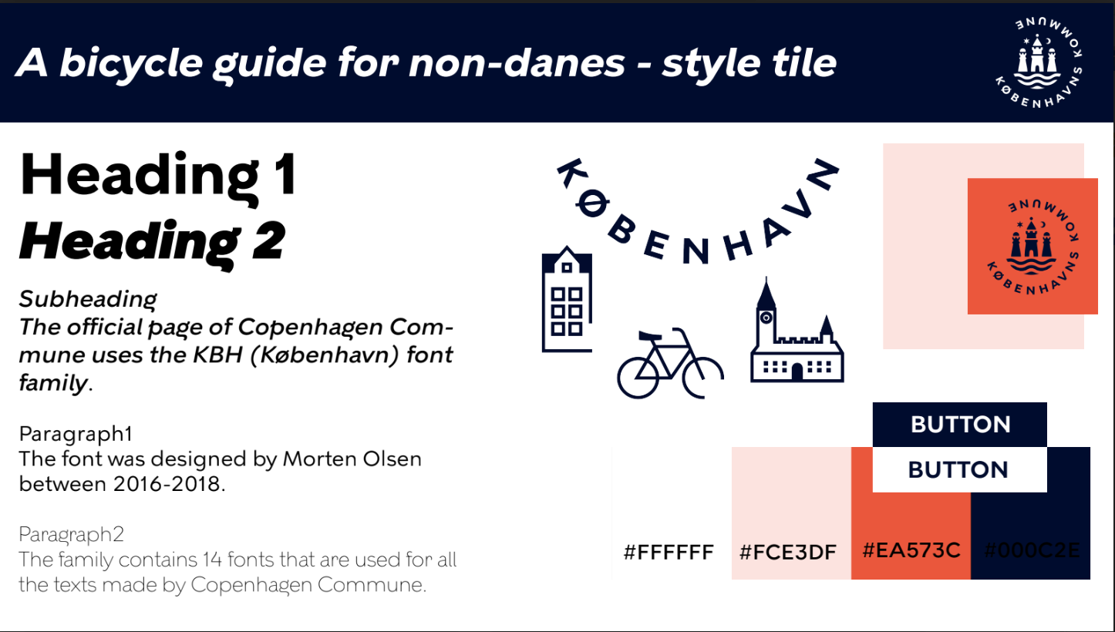

<link to prototype>

### 03.02.05 Link to site

<link to site>

## Theme 04: Basic UX

### 04.01.01 Design Sprint

In our first design sprint we was tasked to create a better version of our current Fronter system.

#### Day1- Map

The first day of the design sprint consisted on making a map, which was basically a diagram with many steps that would lead the user to our long-term goal. Afterwards we selected our target group, which ended up being the students of KEA.

Once we already knew who our target group was as well as our long-term goal, we had to talk to the experts, which, in this case, would mean that we would ask some questions to representatives of our target group.

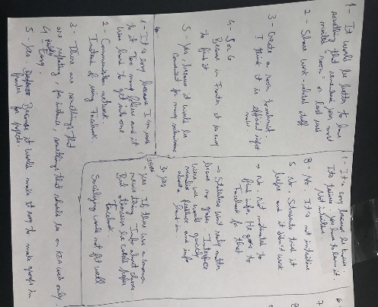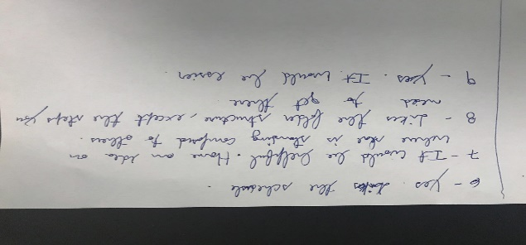

To finish for the day, we created How Might We notes, where we asked some questions, based on the interviews, that we want to answer and resolve with our solution.

#### Day2 – Sketches

On the second day of the Design Sprint we started by, individually, take notes and write down some ideas about the user flow we intended for the prototype that would later be developed.

After that, each element of the group sketched 8 key ideas in a sheet of paper, that would later be a target of voting, where each member should vote on 3 different ideas from all the sketches.

To end the day, we designed a storyboard of the 3 most compelling sketches as demonstrated on the following images.

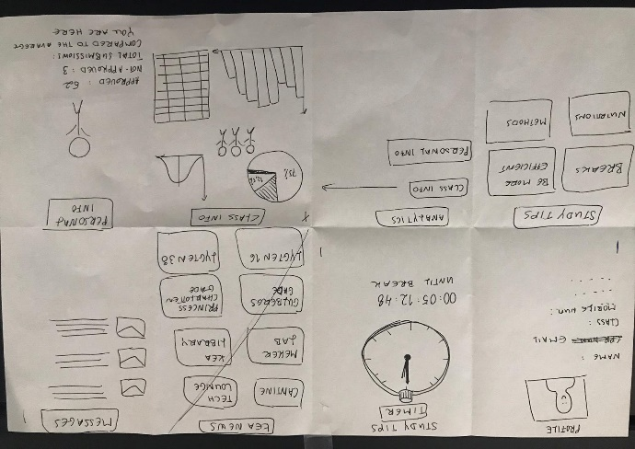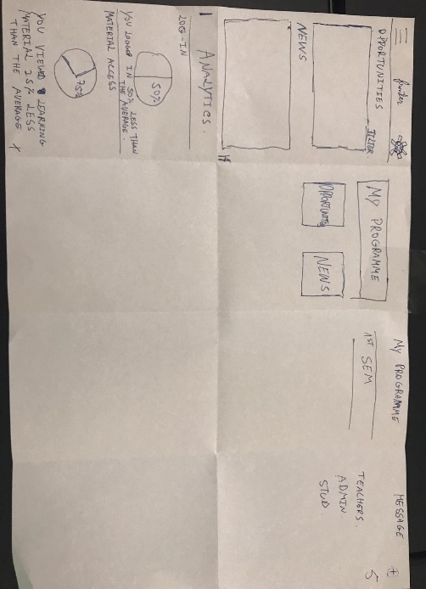

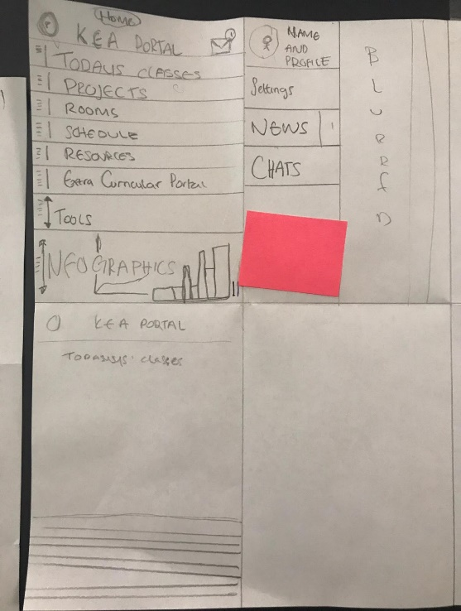

##### Storyboards

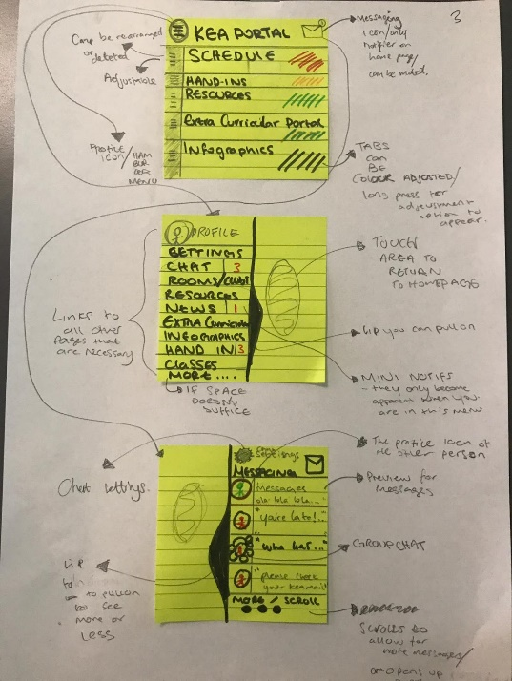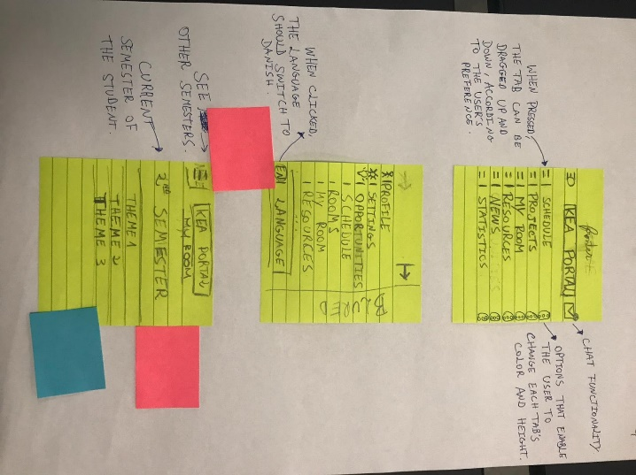

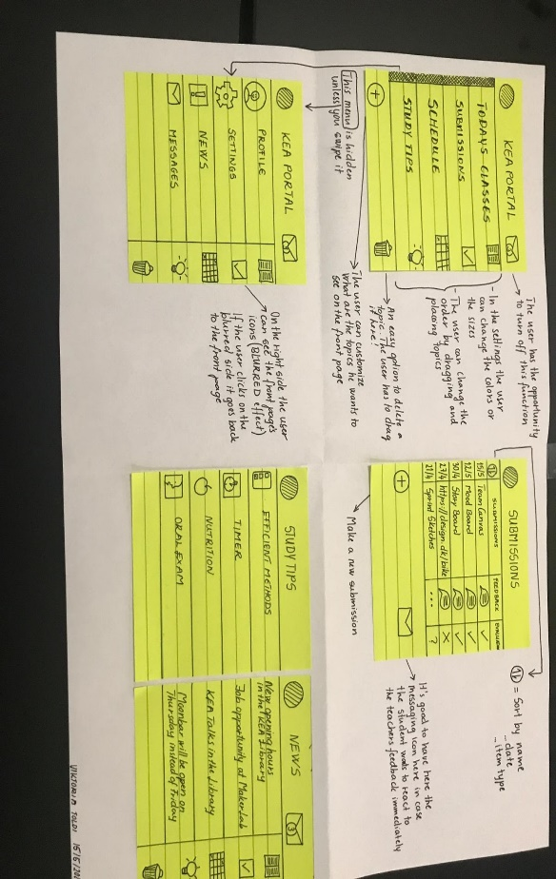

#### Day3 -Decide

The third day of the Design Sprint was mainly about decision and merging all the feedback and ideas between us, the team members, and coming up with a more defined storyboard.

We started off by talking about the ideas we liked the most about the storyboards and the sketches, and argued about better solutions.

After having settled the main ideas and changes we agreed on, we started drawing the storyboard on a whiteboard, and we realized that the general structure we came up with in the storyboard was completely different than the sketches and 3 storyboards we had done the day before.

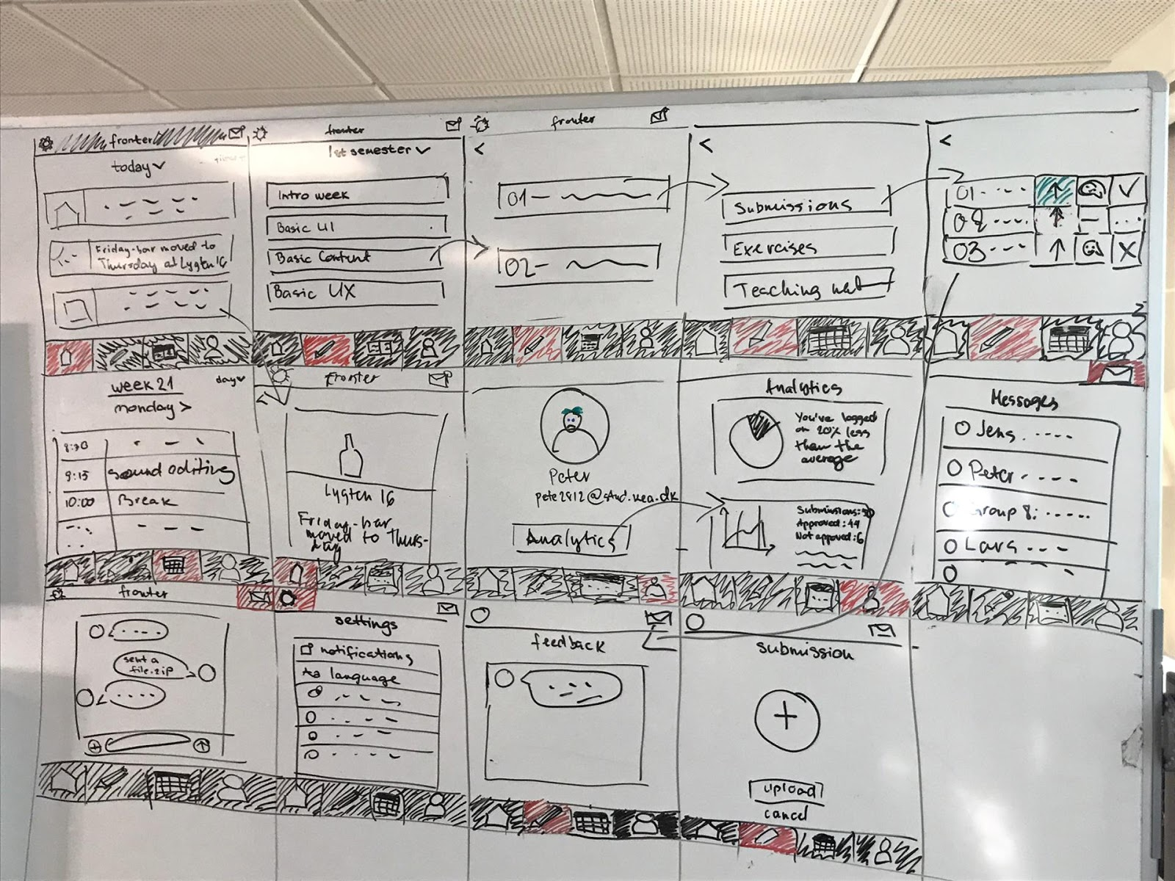

#### Day4 - prototype

This entire day was spent on developing the prototype itself, for our solution, and we managed to work efficiently, since the day before, we had already split some tasks and planned for the current day.

<https://xd.adobe.com/view/d266ac25-b113-4c0e-7f62-c93c7e2b4b4a-a457/screen/97229f77-1e9c-4b1f-a55d-11d0155076fc/Landing-page/> - Link for the Fronter Prototype

#### Day5

This was the final day of our sprint, when we had the chance to test our “product’ by conducting a trunk test, and interviewing the target group. We started by creating the questions we wanted to be answered during the interview, which where the following:

Demographic starting questions:

* What is your age?
* Where are you from?
* (If you are not from Denmark) How long have you been here?
* What are you studying at KEA?

Product related questions:

* What was your first impression of this system?
* Who do you think this system was intended for?
* What is the purpose of this digital solution according to you?
* What do you think about including analytics in our solution?
* What do you think about including a messaging service?
* Where can you find your schedule? Was it easy to find?
* When and where do you first encounter a problem/issue?
* How can we make it more user friendly, more intuitive?
* Do you have any last comments/ suggestions with regards to this system?

Then we started the trunk test and we wrote down the feedback we received.

Based on the feedback, we wrote down the main ones:

* Positive
  + All the interviewees answered correctly to our intended target group.
  + Really simple and user friendly way of presenting info, not complicated.
  + Everything is handy.
  + Feels more fresh.
  + Analytics are easy to understand.
  + Messaging function is convenient.
  + In line with KEA’s visual identity.
  + The pinned tabs are a good idea.
* Negative:
  + The messaging icon wasn’t perceived as such.
  + Pencil icon for the teaching material page, would be confused for resembling a page with an input field.
  + The schedule icon should have more detail, so its meaning is more noticeable.
  + The submissions page should be organized in a more logical way ( maybe the task descriptions tab should be moved outside to the outside of that page).
  + Analytics may be a distraction.
  + The + icon on the pinned tabs was misunderstood by one user.
  + The schedule should also be an option to add to the pinned area on the main page.
  + Needs to be more visually appealing.
  + Too much information on the settings page.
  + It would be nice to be able to connect directly to other learning platforms, such as Vimeo, youtube, LinkedIn Learning).

After reflecting on the feedback from our interviews, we decided to select the issues we think should be prioritised:

* The teaching material, messaging, and schedule page’s icons should be redesigned.
* The folder structure in the submissions tab should be modified to make it more user friendly.
* Settings page should be better implemented.
* Improve some design features to give more emphasis on some things.
* The pinned tabs section on the main page should be rethought to make it more appealing, visually.

### 04.02.01 Web Prototype

In this module I decided to focus on one solution from the previous design sprint. The problem was that the current Fronter has a news section and updates that are vital to the user. This information is often lost in other webpages as it is not directly in front of the user as they go about their clicks.

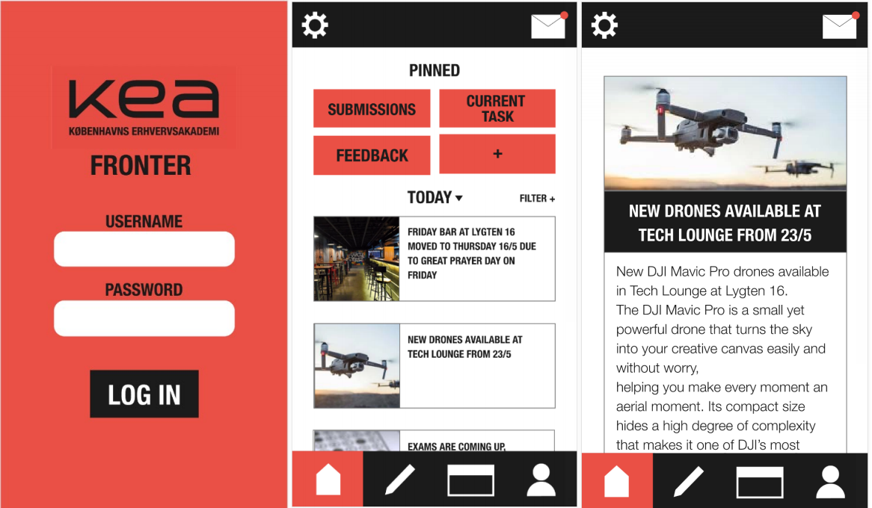

From left to right, the first image is of the logo page, the second is of the homepage with the newsfeed and the third image is of the article page.

#### Work process and selected code snippets with explanations.

So the first thing I began to do was work from a mobile first mentality, and the first thing I decided to tackle was the login page. I animated the login page so that the login form does a slight wink. This wink is to encourage a sense of creativity and friendliness for the students. Below are screen shots of this animation.

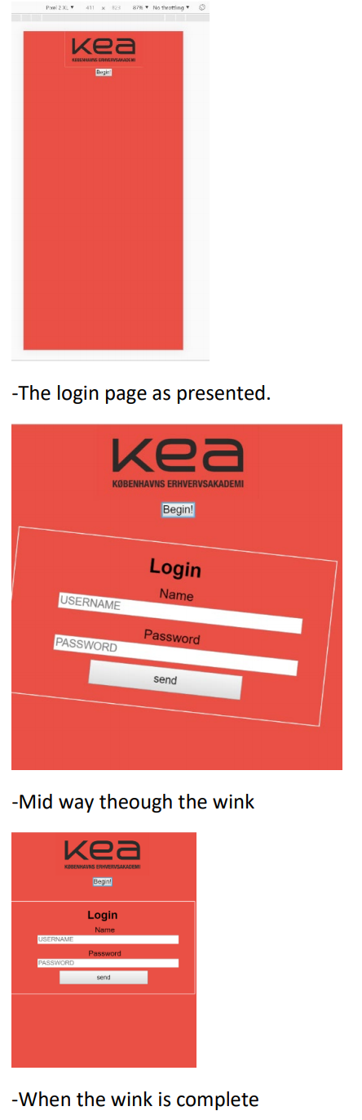

#### Code snippets

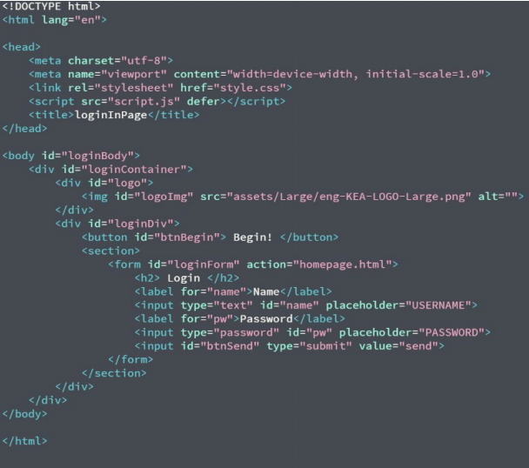

Above is the HTML form for the login page, its simple page with a loginContainer that has a grid, which then also contains logo section and loginDiv. In the login div you have a button followed by a section tag which contains a login form.

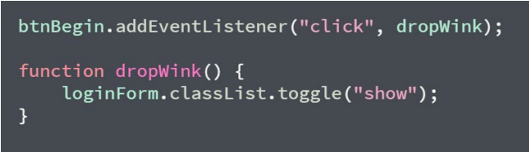

In the java script snippet above, you can see that there is a listener on the button called btnBegin that executes the dropWink function upon “click”. The dropWink function just toggles the classList for the loginForm. Show class can be seen below in the css snippet.

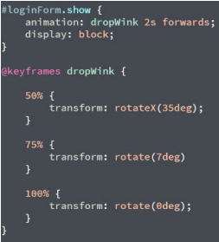

Above is a css snippet that contains the class show and the dropWink keyframes, the class show has a css animation that takes the keyframe information in dropWink, then sets a timer of 2s with a forward motion.

#### Testing

###### Code validation-

The html and css are both validated.

###### 5 second test-

5 second test on the login page. 4 candidates, after showing each candidate the login page for 5 seconds I asked them the following questions. What do you remember? 1. red, KEA LOGO, and a button 2. red, BLACK LOGO and a button that says begin 3. red, KEA logo, black text, button, white button. 4. red, black, logo and a button.

###### Questions

What do you think the purpose of the page is?

1. I know of KEA, so its like intended for students? but its difficult to tell. ¨
2. There was a begin button, I think it’s to represent a splash screen.
3. I have no idea until I press the begin button
4. Its some sort of promotional page, since you have the logo and that’s it

What do you think begin button does?

1. it will take me to the next page
2. it will display an animation of some sort, like the do in games
3. allow me to access site
4. present a questionnaire of some sort.

The reason I chose to conduct a 5 second test on the login page is that it is the first page the user sees and it actually holds no immediate function which may cause the user to click away from the site straight away.

###### Think-aloud tests

I then conducted a think aloud test as I wanted in depth feedback from each user of what they are thinking as they are to fulfil a desires goal of “can you figure out what is happening today?”.

* The first individual, was impressed with the login form as the animation unfolded, saying oh, that’s cool. Then the user paused to look at me thinking what is the login information. They then proceeded to input a generic username, then skipped the password to see if it will work anyways. Once it did work for them they then proceeded to the homepage, “oh interesting its an app, but for what, they proceeded to try and press the non-functioning pin area, quickly proceeding to the news feed. “I see its underlined, is it a link?” and they proceeded to the article page, noting that the date was actually incorrect.
* The second user, was not all that impressed by the animation on the login page at first, “huh, where’s it going” when the animation was over, “did it just wink ‘ahah’, I think the login section just winked at me” they then completely skipped the login form and pressed submit. The user upon Hudeifer Esa 04.02.01 Web prototype seeing the home page “oh cool its an app, but on a website interesting” then proceeded to say “that’s easy, it says today right there” “I’m pressing the image now” then they proceeded to the article page. They were actually disappointed by the lorem Ipsum section of the main article noting “that’s informative” with some purposeful sarcasm.
* The third user, “ oh cool, so red” was the first thing they uttered followed by “lets begin” as they pressed the begin button “that’s weird but kina cool, I don’t usually see that happen”. Then they also paused and then said “ username, well i don’t see a sign up button or indicator” then they proceeded to input their desired details, the user even added a password and then clicked submit which took them to the homepage “I didn’t really have input any data did i?” they user remarked as they laughed. “okay, what is happening today” the tested began to browse saying “not much is happening I guess”. “I am now clicking the underlined
* The fourth user, “clicking begin” as they pressed the begin button “oh okay that’s cool, wish it was faster though”. “cool, I like the app look of this site, like I like the icons. Very cool.” “okay, i see today title. ” “I am now clicking the link, or the image, i guess i’ll try the image” and when the user reached the article page the user remarked, “ oh so it was the image that was the link” and also remarked “the date is incorrect but I like the layout”.

The reason I chose to conduct a think out loud test is to gage what the user thinking as they are using the system. This allows me to see issues that I as the developer were too close to seeing, but a user who doesn’t know how its developed may notice as they have fresh eyes.

###### Analysis of test results.

From the 5 second test, I quickly learned that on first impression without the login form present the login page is not very informative. Its also very simple, and thus the user is actually interested in clicking the begin button. From the think-aloud tests, i learned that the animation on the animation, is welcomed by some users but is always a surprise. Then as the user proceeds they find it relatively easy to navigate to the news feed and the article. The site is very simple, so the user finds it easy to spot what they are looking for. Another unintended thing occurred frequently which is that the user found the underlined text to be more obvious a link then the image, but some users went for the image. One user even referred to the header as a ‘link’ whilst others assumed so because of the underlined text.

###### Needed Adjustments

The needed adjustments are the following:

* It may be wise to contain a little information before the begin button, something that would indicate clearly that it is a login page.
* Secondly I noticed the slightest of issues with the speed of the animation because the user thinks when the form drops forward that the animation is complete and tries to proceed but then realises animation isn’t completely over. I’m assuming at first impression its fine, but with repetitive use it will get boring and tiring fast.
* Also I could add a hover element on the article text and article Image on the newsfeed so that when the user hovers over either the whole section becomes illuminated in some way, indicating to the user that they can press anywhere.